Methodology
This study utilised the global urban microbiome metadata provided by the MetaSUB consortium to screen and clean 664 subway environmental samples in the London area. By quantifying the distribution differences at different stations, surface materials, and geographic spaces through sequencing, the study evaluated the accumulation patterns of bioaerosols in the London underground transportation system and their potential indicative effects on air quality.
Literature Review
The environmental characteristics of urban underground transportation system, as a unique ecological niche with closed and high pedestrian flow, have attracted widespread attention from the academic community. Based on MetaSUB data, Danko et al. (2021) drew a global urban microbial map and established that the subway environment is mainly affected by human and soil environmental bacteria. These pioneering studies have confirmed that surface microorganisms on subways are not randomly distributed, but are influenced by the interaction between human activities and the environment, providing a methodological basis for us to use surface samples in the environment as proxy indicators for air biological deposition.
However, there are still significant research gaps in existing literature. Existing research focuses on horizontal comparisons between global cities, often overlooking the complex spatial heterogeneity within a single city. Regarding London, the world's oldest and most complex subway system with deep and shallow lines, existing environmental research mainly focuses on the analysis of physical and chemical pollutants such as metal dust and PM2.5, while lacking research on different stations from the perspective of microbial load. In addition, the current discussion on how the station microenvironment affects the retention and resuspension of biological particles is still insufficient.
This study utilized metaSUB to analyze microbial metadata in the London area subway. This method reflects the local differences in air quality and ventilation conditions of the London Underground.
Data source
Dataset Name: MetaSUB Complete Metadata (London Subset)
Provider: The MetaSUB International Consortium
1. Key Variables & Definitions
- num_read as the quantity of biological substances. The higher of the num_read, the more biomass has accumulated.
- Station_name as the name of London Underground station. Station_name represents the key area of microbial aggregation with the London Underground.
- Surface_material represents the surface material of an object. This value reflects the adhesion of pollutants to different materials.
- Sample_date represents the category of the sample.
2. Cleaning & Inclusion Rules
In order to achieve data analysis, we cleaned and organized the raw data, and the specific steps are as follows:
- Location filtering only filters data with the city field of London, thus completing the analysis of the environment inside the London subway.
- Station filtering: The station column is not set in the original data, so we use logical inference to organize the content of the line column as station_name. For samples without specific site information, mark them as Control/Unknown and exclude them from site specific analysis.
- Missing value handling: For NaN and invalid characters in surface_material, they are uniformly marked as Unknown.
- Data type conversion: For the convenience of data statistics and analysis, we convert num_deads in the dataset to numeric values, and force non numeric entries to NaN and remove them to ensure the validity of statistical calculations.
Next, we will conduct data analysis and visualization based on the cleaned data.

Firstly, we counted the microbial count at each station of the London Underground, which indicates the key areas of biomass accumulation in the London Underground. The analysis results indicate that high readings are associated with high passenger flow or poor ventilation. In the subway environment, as bacteria usually attach to dust particles and skin debris for transmission, these "high microbial load" stations are likely to be areas with heavy air particle pollution.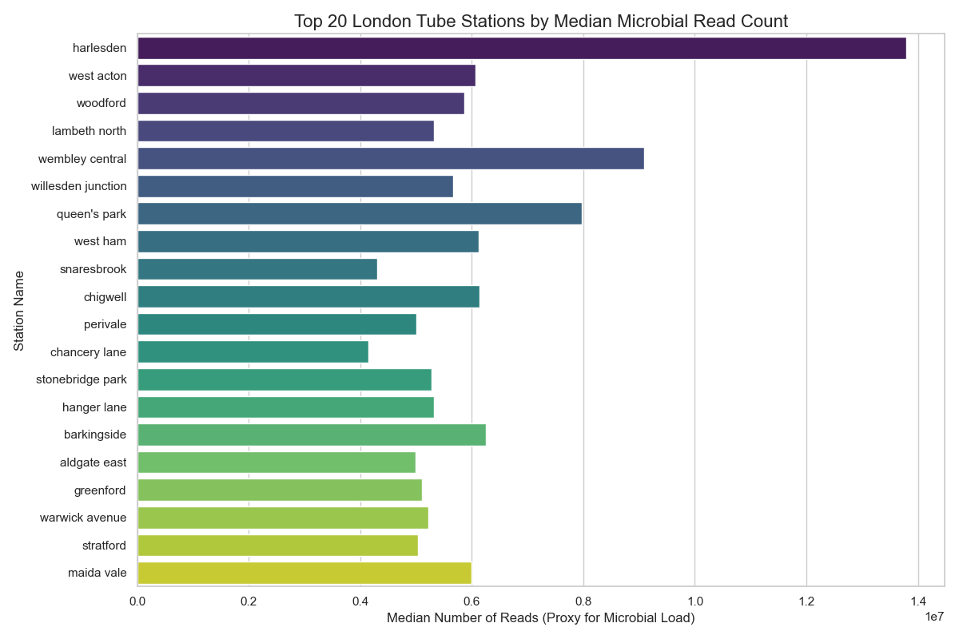
Secondly, we further analyzed which materials microorganisms tend to accumulate on in the subway. Experimental results showed that wood and plastic surfaces had higher microbial loads compared to glass or metal. Therefore, metal handrails and glass windows in the subway are not the main accumulation sites for microorganisms; microorganisms are more likely to remain suspended in the air or settle on the ground/wooden benches, continuously affecting air quality.
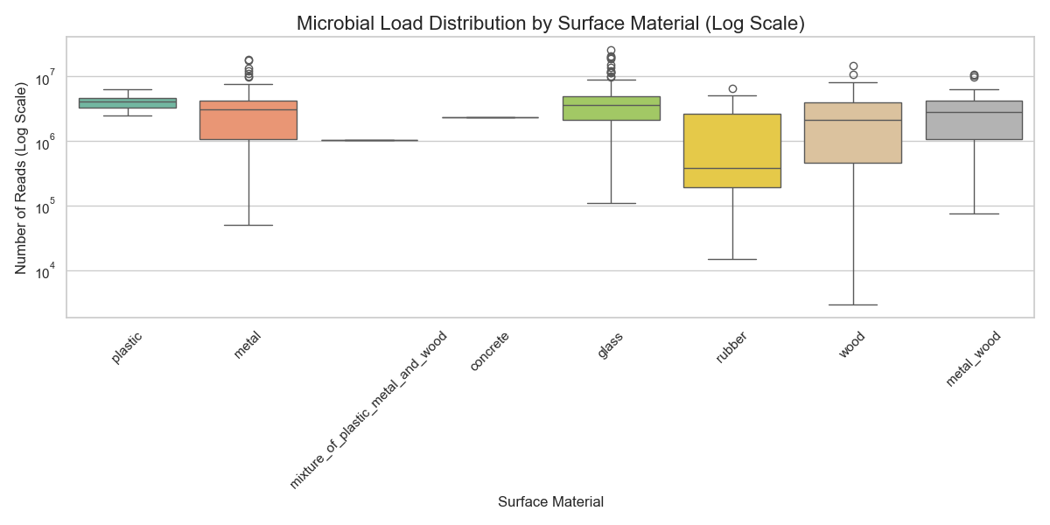
Furthermore, we demonstrate the distribution patterns of the environment in geographic space. Data analysis results show that the bio-air quality of the London Underground is not solely determined by geographical location, but is influenced by manual local environmental factors (such as station depth, the aging of the ventilation system, and specific passenger density).
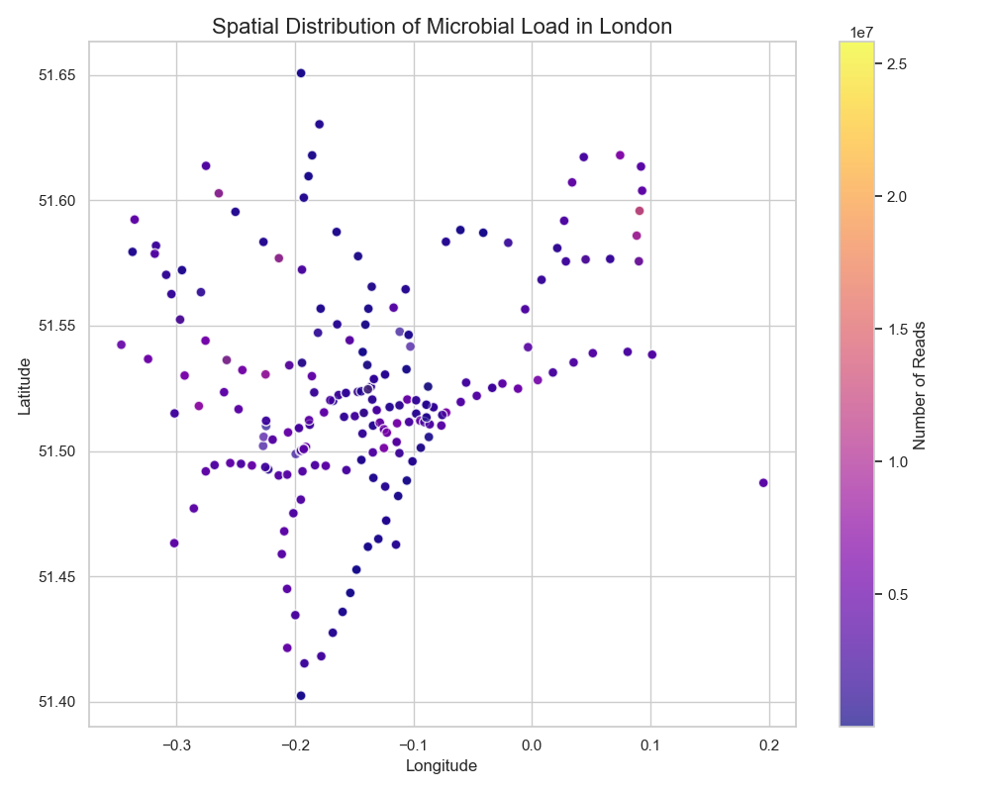
Code
Data clean

import pandas as pd
def clean_london_metadata(input_file, output_file):
df = pd.read_csv(input_file)
target_cities = ['london', 'islington', 'kensington']
london_df = df[df['city'].isin(target_cities)].copy()
london_df['line'] = london_df['line'].fillna('Control/Unknown')
london_df = london_df.rename(columns={'line': 'station_name'})
london_df['surface_material'] = london_df['surface_material'].fillna('Unknown')
london_df['surface_material'] = london_df['surface_material'].replace('-', 'Unknown')
selected_columns = [
'uuid',
'city',
'station_name',
'latitude',
'longitude',
'surface_material',
'sample_type',
'num_reads',
'control_type'
]
london_cleaned = london_df[selected_columns]
london_cleaned.to_csv(output_file, index=False)
print(london_cleaned.head())
print(london_cleaned.info())
if __name__ == "__main__":
input_csv = 'complete_metadata.csv'
output_csv = 'london_subway_metadata_cleaned.csv'
clean_london_metadata(input_csv, output_csv)

Visualization
import pandas as pd
import matplotlib.pyplot as plt
import seaborn as sns
# 1. Re-load and clean data (to ensure we have the dataframe ready)
df = pd.read_csv('complete_metadata.csv')
target_cities = ['london', 'islington', 'kensington']
london_df = df[df['city'].isin(target_cities)].copy()
london_df['line'] = london_df['line'].fillna('Control/Unknown')
london_df = london_df.rename(columns={'line': 'station_name'})
london_df['surface_material'] = london_df['surface_material'].fillna('Unknown')
london_df['surface_material'] = london_df['surface_material'].replace('-', 'Unknown')
# Convert num_reads to numeric, coerce errors just in case
london_df['num_reads'] = pd.to_numeric(london_df['num_reads'], errors='coerce')
# Filter out controls for the main station analysis to focus on actual stations
station_data = london_df[london_df['station_name'] != 'Control/Unknown'].copy()
# Set up the visualization style
sns.set(style="whitegrid")
# Visualization 1: Top 20 Stations by Median Microbial Load (num_reads)
# Using median is more robust to outliers than mean
top_stations = station_data.groupby('station_name')['num_reads'].median().sort_values(ascending=False).head(20).index
plt.figure(figsize=(12, 8))
sns.barplot(x='num_reads', y='station_name', data=station_data[station_data['station_name'].isin(top_stations)],
order=top_stations, palette='viridis', errorbar=None)
plt.title('Top 20 London Tube Stations by Median Microbial Read Count', fontsize=16)
plt.xlabel('Median Number of Reads (Proxy for Microbial Load)', fontsize=12)
plt.ylabel('Station Name', fontsize=12)
plt.tight_layout()
plt.savefig('top_20_stations_microbial_load.png')
material_data = london_df[~london_df['surface_material'].isin(['Unknown'])]
plt.figure(figsize=(12, 6))
sns.boxplot(x='surface_material', y='num_reads', data=material_data, palette='Set2')
plt.yscale('log') # Log scale is often better for sequencing data ranges
plt.title('Microbial Load Distribution by Surface Material (Log Scale)', fontsize=16)
plt.xlabel('Surface Material', fontsize=12)
plt.ylabel('Number of Reads (Log Scale)', fontsize=12)
plt.xticks(rotation=45)
plt.tight_layout()
plt.savefig('microbial_load_by_material.png')
geo_data = london_df.dropna(subset=['latitude', 'longitude', 'num_reads'])
plt.figure(figsize=(10, 8))
sc = plt.scatter(geo_data['longitude'], geo_data['latitude'],
c=geo_data['num_reads'], cmap='plasma',
alpha=0.7, s=50, edgecolors='w', norm=plt.Normalize(vmin=geo_data['num_reads'].min(), vmax=geo_data['num_reads'].max()))
plt.colorbar(sc, label='Number of Reads')
plt.title('Spatial Distribution of Microbial Load in London', fontsize=16)
plt.xlabel('Longitude', fontsize=12)
plt.ylabel('Latitude', fontsize=12)
plt.tight_layout()
plt.savefig('spatial_distribution_london.png')
print("Visualizations generated.")

Research Results
This result indicates that the air quality of the subway is affected by human activities, and hot subway stations correspond to areas with poor air circulation or dense crowds, where the environment will be significantly affected.

Reference: Danko, D., et al. (2021). A global metagenomic map of urban microbiomes. Cell, 184(13), 3376-3393.

